# Chapter 19: Expressionism

Portions of the following text are taken from smarthistory.org, which is available for use under CC BY-NC-SA. Please see the citations at the bottom of the page for more information. The text has been adapted to more closely adhere to Chicago Manual of Style and Ensign College Style Guide.

Imagine a painting where the magentas scream, the greens glare, and coarse brushstrokes become more ominous the longer you look at them. Paintings like this, where the artist uses color, line, and visible techniques to evoke powerful responses from the viewer date from the early 20th century but continue expressive traditions that can be found throughout art’s history (see, for example, work by Francisco Goya). When labeled as expressionism, however, the term refers more specifically to an artistic tendency that became popular throughout Europe in the early 20th century. Like many categories in art history, expressionism was not a name coined by artists themselves. It first emerged around 1910 as a way to classify art that shared common stylistic traits and seemed to emphasize emotional impact over descriptive accuracy. For this reason, artists like Edvard Munch, in paintings like his famous The Scream, straddle the line between postimpressionist developments in late 19th-century painting and early 20th-century expressionism. Likewise, the Fauves in France exhibited similar characteristics in their work and are often linked to expressionism, such as Henri Matisse's The Red Studio.

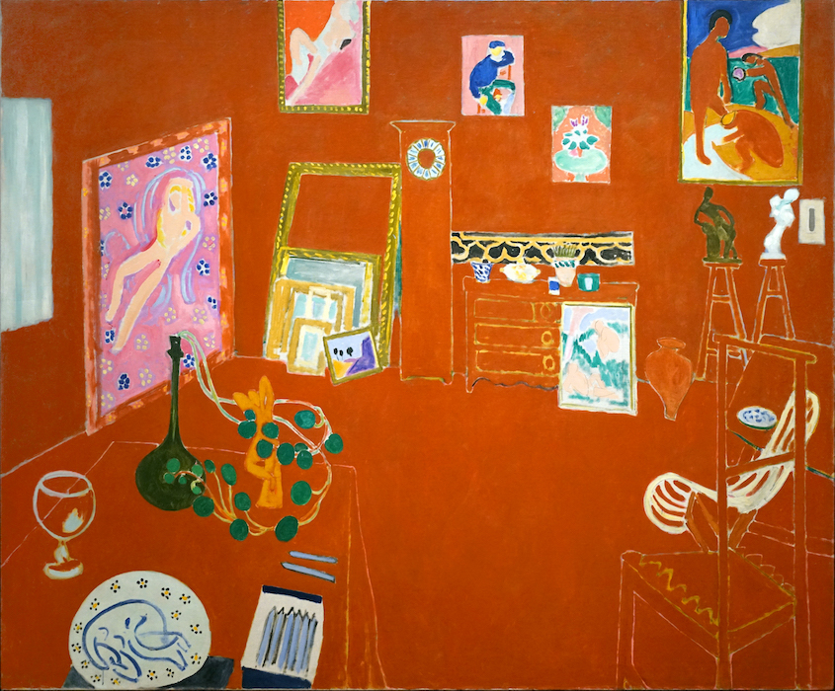

### Expressionism in Germany

Though many artists of the early 20th century can accurately be called expressionists, two groups that developed in Germany, Die Brücke (The Bridge) and Der Blaue Reiter (The Blue Rider), are among the best known and help to define the style. Influenced in part by the spiritual interests of Romanticism and symbolism, these artists moved further from the idealized figures and smooth surface of 19th-century academic painting. Instead of depicting the visible exterior of their subjects, they sought to express profound emotional experiences through their art. German expressionists, like other European artists of the time, found inspiration in so-called “primitive” sources that included African art, as well as European medieval and folk art and others untrained in Western artistic traditions. For the expressionists, these sources offered alternatives to established conventions of European art and suggested a more authentic creative impulse.

#### Die Brücke

In 1905, four young artists working in Dresden and Berlin joined together, calling themselves Die Brücke (The Bridge). Led by Ernst Ludwig Kirchner, the group wanted to create a radical art that could speak to modern audiences, which they characterized as young, vital, and urban. Drawn from the writings of Friedrich Nietzsche, the 19th-century German philosopher, the name Die Brücke describes their desire to serve as a bridge from the present to the future. While each artist had his own personal style, Die Brücke art is characterized by bright, often arbitrary colors and a “primitive” aesthetic, inspired by both African and European medieval art. Their work often addressed modern urban themes of alienation and anxiety, as well as sexually charged themes in their depictions of the female nude.

Their first exhibition was held in the showroom of a lamp factory in Dresden in 1906, for which they published a program of woodcut prints reflecting their interest in earlier traditions of German art. In the introductory broadsheet, Kirchner made clear the group’s revolutionary intentions. He proclaimed,

"With faith in progress and in a new generation of creators and spectators we call together all youth. As youth, we carry the future and want to create for ourselves freedom of life and of movement against the long established older forces."

This optimism was not long-lived. Internal squabbling caused the group to dissolve in 1913 just prior to the start of the First World War.

#### Der Blaue Reiter

Based in the German city of Munich, the group known as Der Blaue Reiter lasted only from their first exhibition at the Galerie Thannhausen in 1911 to the outbreak of World War I in 1914. Created as an alternative to Kandinsky’s previous group, the more conservative Neuen Künstlervereinigung München (New Artists Association of Munich or NKVM), Die Blaue Reiter took its name from the motif of a horse and rider, often used by founding member Vasily Kandinsky.

This motif appeared on the cover of the Blue Rider Almanac, published in May 1912, and reflects Kandinsky’s interest in medieval traditions and the folk art of his Russian homeland. In contrast to Die Brücke, whose subjects were physical and direct, Kandinsky and other Die Blaue Reiter artists explored the spiritual in their art, which often included symbolism and allusions to ethereal concerns. They thought these ideas could be communicated directly through formal elements of color and line, that, like music, could evoke an emotional response in the viewer. Conceived by Kandinsky and Franz Marc, the almanac included essays by themselves and other German and Russian artists, musical compositions by expressionist composers, such as Arnold Schönberg, and Kandinsky’s experimental theater piece, Der gelbe Klang (The Yellow Sound). This range of content shows Der Blaue Reiter’s efforts to provide a philosophical approach not just for the visual arts, but for culture. These ideas would become more fully developed at the Bauhaus, where Kandinsky taught after the war (Marc died during the Battle of Verdun in 1916).

**Video Transcript**

We're at the Solomon R. Guggenheim Museum in New York City. We're looking at a painting by Vasily Kandinsky. This is Improvisation number 28 (second version). It's interesting to start off by thinking about the title because it's not the title of something that's being represented; it's the kind of notation that a composer uses.

Right, normally in art history, we have paintings with titles of stories from the bible or from history or from mythology or landscapes that have the name of a place, but here we have Improvisation, which is the name of a kind of musical composition. So the immediate question is, why is Kandinsky doing that?

Well, because he's composing here. He's composing with form, but this is still rooted in stories of the bible and of his particular historical moment. But he's clearly trying to associate painting with music, to suggest that like music, painting can signify. It can mean things. It can take us places without representing anything concrete.

Actually, he would go further than that and say that you could hear color, that you could see music, this idea, which is called synesthesia, is something that Kandinsky was very interested in. The idea that there could be a kind of crossing of the senses.

So looking at this, he may have wanted us to actually hear something. And in fact, we know that Kandinsky was very influenced by Arnold Schönberg, a turn-of-the-century composer who was jettisoning the familiar Western harmonies to create a new kind of difficult atonal music for the beginning of the 20th century. And I see something atonal. I see something difficult here.

What would this painting sound like? For me, it would sound like a cacophony. It would sound like chaos. It would sound like a very dangerous but also brilliant moment.

We have brilliant color, a kind of hazy atmosphere through which that color pops. We have these black diagonal lines that crisscross with each other, that almost feel like weapons moving through space.

And it's appropriate that the analogy that you're drawing is one of war. This is 1912. It's just two years before the First World War begins, and early 20th-century Russian history is filled with political chaos.

We're clearly on the verge of abstraction, and in fact, when we first look at this painting, it looks entirely abstract. That is, we don't immediately recognize the things of the world. But this isn't what we would call a completely abstract painting.

Right. So one might not call this painting an abstract painting, but call it an abstracted painting.

So therefore, we should still be able to recognize some elements of the natural world.

Kandinsky was concerned that if we could recognize things too clearly that our conscious minds would take over the interpretation, and we would close off our emotional ability to respond to the pure color and form. In the upper right, I seem to see a mountain with some buildings on it, maybe with chimney stacks, or perhaps a church on a hill, an ideal city, a kind of heavenly Jerusalem. Kandinsky was deeply influenced by biblical imagery, and so even though this is a tremendously modern painting, it is still rooted in this ancient tradition of representing Christian stories.

So it makes sense that we have a battlefield, forces at war.

In fact, art historians have looked at these paintings as a kind of representation of an apocalypse, of a moment when the sins of the world are gonna be washed away. In the lower left, you have a great flood. You have a wave, this idea of the way in which God in the Old Testament had wiped man from the earth except for Noah and his family.

Just above that wave, canons are being fired. The atmospheric effect almost reads like the smoke on a battlefield. Down at the bottom, art historians sometimes recognize the manes and the arcs of the necks of horses and we know that Kandinsky was really interested throughout his career in the idea of the horse and rider. Symbolizing a number of different things, having overlapping meanings, referencing the four horsemen of the apocalypse, but also the idea of redemption.

This was also a utopia. The idea that we could wash away the old world, a world that was about to be destroyed not only by the Russian Revolution but also by The First World War. Kandinsky, at this moment, was convinced that he could help lead that, at least in the visual realm. Many artists at this time, the early 20th century, had a sense that the artist could play an important role in the new civilization that was going to emerge in the 20th century.

So here, we have a painting that is using color in a radically new way. This is color for its own sake, not to mimic, not to describe; we have a line that is being used for its own sake, line that is abstractly moving across the surface to create a sense of rhythm, to create a sense of staccato. Musicality in this painting was absolutely new.

### Questions to Consider

1. Why did the artists of the different styles of German expressionism employ the elements and principles of art in the way that they did? What did they hope to accomplish?
2. How does this style of art connect with philosophical currents at the time?

Read this online at <https://ensign.edtechbooks.org/history_of_the_fine_arts_music/expressionism>