# Chapter 20: Cubism

Portions of the following text are taken from smarthistory.org, which is available for use under CC BY-NC-SA. Please see the citations at the bottom of the page for more information. The text has been adapted to more closely adhere to Chicago Manual of Style and Ensign College Style Guide.

**Video Transcript**

### Cubism

Cubism was developed as a collaboration between Pablo Picasso and Georges Braque.

Building on the work of the postimpressionist painter Cézanne, Cubism presents abstracted shapes and forms from multiple viewpoints simultaneously, while emphasizing the flat, two-dimensional nature of painting. Muted, neutral colors are typically used in order to make form the primary focus of the work.

Cubism evolved in two phases; the analytical phase and the synthetic phase. In the analytical phase, objects are shattered into angular forms that interpenetrate with the surrounding space.

In the synthetic phase, fractured forms are reassembled into a coherent aesthetic object, and incorporate the use of collage and mixed media.

### Futurism

The futurist movement was created by Italian artists and writers upset by the focus placed on Italy’s cultural and artistic past rather than its place in modernity.

The futurists outlined their objectives in the “Futurist Manifesto,” calling for the destruction of museums and libraries and a rejection of the cultural and artistic past in order to move into the modern era.

Futurist art embraces the dynamism and speed of modern technology and exhibits a fascination with motion and a simultaneity of views. This was inspired in part by the development of time-lapse photography.

### Suprematism

Suprematism was developed by the Russian artist Kazimir Malevich. Malevich believed that “pure feeling” was the supreme reality, and wanted to create a non-objective, universal artistic style with which to communicate emotion.

Malevich believed his art needed to move beyond pre-determined, socially constructed meaning to be accessible to all. In order to avoid recognizable meanings and symbols, suprematism works with a simple visual vocabulary of basic, geometric forms and a limited range of colors.

### De Stijl

De Stijl, Dutch for the style, was founded by the Dutch artists Theo van Doesburg and Piet Mondrian. Seeking a complete integration between art and life, De Stijl encompassed art, architecture, and design.

De Stijl valued pure abstraction and simplicity and sought to create a pure artistic language through which the spiritual could be expressed. De Stijl artists wished to use their art and designs to help rebuild society after the chaos and horror of WWI.

De Stijl art exhibits simplicity and balance, order and control. Colors are predominantly limited to primary colors, black, and white, with a focus on vertical and horizontal lines, the square and the rectangle.

Beginning in 1908, and continuing through the first few months of 1912, Georges Braque and Pablo Picasso co-invented the first phase of cubism. Since it is dominated by the analysis of form, this first stage is usually referred to as analytic cubism. Cubism is a terrible name. Except for a very brief moment, the style has nothing to do with cubes. Instead, it is an extension of the formal ideas developed by Paul Cézanne and broader perceptual ideas that became increasingly important in the late 19th and early 20th centuries.

### Analytical Cubism

The young French Fauvist Braque had been struck by both the posthumous Cézanne retrospective exhibition held in Paris in 1907 and his first sight of Picasso’s radical new canvas, Les Demoiselles d’Avignon. Like so many people who saw it, Braque is reported to have hated it—Matisse, for example, predicted that Picasso would be found hanged behind the work, so great was his mistake. Nevertheless, Braque stated that it haunted him through the winter of 1908. Like every good Parisian, Braque fled Paris in the summer and decided to return to the part of Provence in which Cézanne had lived and worked. Braque spent the summer of 1908 shedding the colors of Fauvism and exploring the structural issues that had consumed Cézanne and now Picasso. He wrote,

It [Cézanne’s impact] was more than an influence, it was an invitation. Cézanne was the first to have broken away from erudite, mechanized perspective.

Like Cézanne, Braque sought to undermine the illusion of depth by forcing the viewer to recognize the canvas not as a window, but as it truly is, a vertical curtain that hangs before us. In canvases such as Houses at L’Estaque ( 1908), Braque simplifies the form of the houses (here are the so-called cubes), but he nullifies the obvious recessionary overlapping with the trees that force forward even the most distant building.

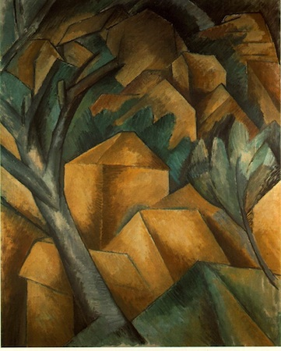

When Braque returned to Paris in late August, he found Picasso an eager audience. Almost immediately, Picasso began to exploit Braque’s investigations. But far from the end of their working relationship, this exchange became the first in a series of collaborations that lasted six years and created an intimate creative bond between these two artists that is unique in art history.

Between the years 1908 and the beginning of the First World War in 1914, Braque and Picasso worked together so closely that even experts could have difficulty telling the work of one artist from the other. For months on end, they would visit each other's studio on an almost daily basis sharing ideas and challenging each other as they went. Still, a pattern did emerge, and it tended to be to Picasso’s benefit. When a radical new idea was introduced, more than likely, it was Braque who recognized its value. But it was inevitably Picasso who realized its potential and was able to fully exploit it.

By 1910, cubism had matured into a complex system that is seemingly so esoteric that it appears to have rejected all esthetic concerns. The average museum visitor, when confronted by a 1910 or 1911 canvas by Braque or Picasso, the period known as analytic cubism, often looks somewhat put upon even while they may acknowledge the importance of such work. Cubism is an analysis of vision and its representation, and it is challenging. As a society, we seem to believe that all art ought to be easily understandable or at least beautiful. Cubism, however, is neither of those things.

### Synthetic Cubism

But then, during the summer of 1912, Braque leaves Paris to take a holiday in Provence. During his time there, he wanders into a hardware store, and there he finds a roll of oilcloth. Oilcloth is an early version of contact paper, the vinyl adhesive used to line the shelves or drawers in a cupboard. Then, as now, these materials come in a variety of pre-printed patterns. Braque purchased some oilcloth printed with a fake wood grain. That particular pattern drew his attention because he was at work on a cubist drawing of a guitar, and he was about to render the grain of the wood in pencil. Instead, he cut the oilcloth and pasted a piece of the factory-printed grain pattern into his drawing. With this collage, Braque changed the direction of art for the next 90 years.

As you might expect, Picasso was not far behind Braque. Picasso immediately begins to create collage with oil cloth as well—and adds other elements to the mix (but remember, it was really Braque who introduced collage—he never gets enough credit). One of the keys to understanding the importance of cubism, of Picasso and Braque, is to consider their actions and how unusual they were for the time. When Braque and then Picasso placed industrially-produced objects (“low” commercial culture) into the realm of fine art (“high” culture) they acted as artistic iconoclasts by questioning the elitism of the art world, which had always dictated the separation of common, everyday experience from the rarefied, contemplative realm of artistic creation.

Of equal importance, their work highlighted—and separated—the role of technical skill from art-making. Braque and Picasso introduced a “fake” element on purpose; not to mislead or fool their audience, but rather to force a discussion of art and craft, of high and low, of unique and mass-produced objects. They ask, “Can this object still be art if I don’t actually render its forms myself, if the quality of the art is no longer directly tied to my technical skills or level of craftsmanship?”

### Still-Life with Chair Caning, Picasso

Virtually all avant-garde art of the second half of the 20th century is indebted to this brave renunciation. But that doesn’t make this kind of cubism, often called synthetic cubism (piecing together, or synthesis of form), any easier to interpret. At first glance, Picasso’s Still-Life with Chair Caning of 1912 might seem like a mishmash of forms instead of a clear picture. But we can understand the image—and others like it—by breaking down cubist pictorial language into parts. Let’s start at the upper right: almost at the edge of the canvas (at two o’clock) there is the handle of a knife. Follow it to the left to find the blade. The knife cuts a piece of citrus fruit. You can make out the rind and the segments of the slice at the bottom right corner of the blade.

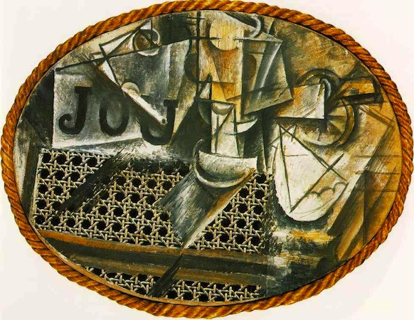

Below the fruit, which is probably a lemon, is the white, scalloped edge of a napkin. To the left of these things and standing vertically in the top center of the canvas (12 o’clock) is a wine glass. It’s hard to see at first, so look carefully. Just at the top edge of the chair caning is the glass’s base, above it is the stem (thicker than you might expect), and then the bowl of the glass. It is difficult to find the forms you would expect because Picasso depicts the glass from more than one angle. At 11 o’clock is the famous “JOU,” which means game in French, but also the first three letters of the French word for newspaper (or more literally, daily; journal=daily). In fact, you can make out the bulk of the folded paper quite clearly. Don’t be confused by the pipe that lies across the newspaper. Do you see its stem and bowl?

But there are still big questions: Why the chair caning? What is the gray diagonal at the bottom of the glass? And why the rope frame? (Think of a ship’s port hole. The port hole reference is an important clue.) Also, why don’t the letters sit better on the newspaper? Finally, why is the canvas oval? It has already been determined that this still life is composed of a sliced lemon, a glass, a newspaper, and a pipe. Perhaps this is a breakfast setting, with a citron pressé (French lemonade). In any case, these items are arranged on a glass tabletop. You can see the reflection of the glass. In fact, the glass allows us to see below the table’s surface, which is how we see the chair caning—which represents the seat tucked in below the table.

Okay, so far so good. But why is the table elliptical? This appears to be a café table, which is round or square but never oval. Yet, when we look at a circular table, we never see it from directly above. Instead, we see it at an angle, and it appears elliptical in shape as we approach the table to sit down. But what about the rope, which was not mass-produced, nor made by Picasso, but rather something made especially for this painting? We can view it as the bumper of a table, as it was used in some cafés, or as the frame of a ship’s port hole, which we can look “through,” to see the objects represented. The rope’s simultaneous horizontal and vertical orientation creates a way for the viewer (us) to read the image in two ways—looking down and looking through/across. Put simply, Picasso wants us to remember that the painting is something different from that which it represents. Or as Gertrude Stein said, “A rose is a rose is a rose.”

**Video Transcript**

HIDDEN CONTENT

### 

Read this online at <https://ensign.edtechbooks.org/history_of_the_fine_arts_music/cubism>