Unit 6 Additional Readings

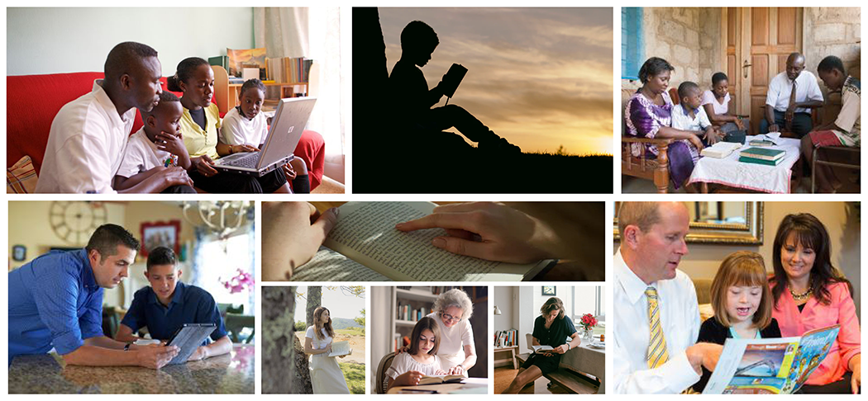Elder Quentin L. Cook, “Let There Be Light”

Elder M. Russell Ballard, “Let Our Voices Be Heard”

Elder Dallin H. Oaks, “Religious Freedom”

Elder Jeffrey R. Holland, “Israel, Israel, God Is Calling"

Elder Dallin H. Oaks, “Protect The Children”

Elder Dallin H. Oaks, “Truth and Tolerance”

Elder Robert D. Hales, “Preserving Agency, Protecting Religious Freedom”

Elder Richard G. Scott, "To Heal the Shattering Consequences of Abuse"
Read this online at https://ensign.edtechbooks.org/religion_200c_2nd_edition_/unit_6_additional_re

