# Public Submissions

In some cases, you may want to solicit contributions to your publication from the public, such as if you are creating a collection of conference proceedings or creating a journal volume. You can temporarily allow public submissions to your publication by adjusting the Public Submissions setting on your publication's Authorship page.

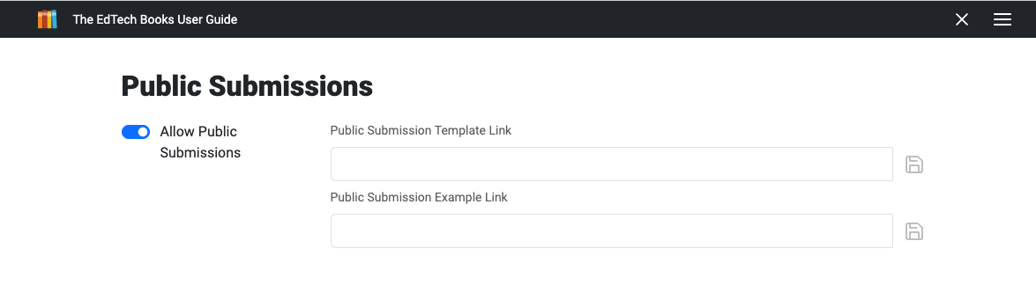

Once you turn on Public Submissions, navigate back to the cover page of your publication. There you will see a persistent reminder that public submissions are allowed, and it will also provide a link to the publication's public submission page.

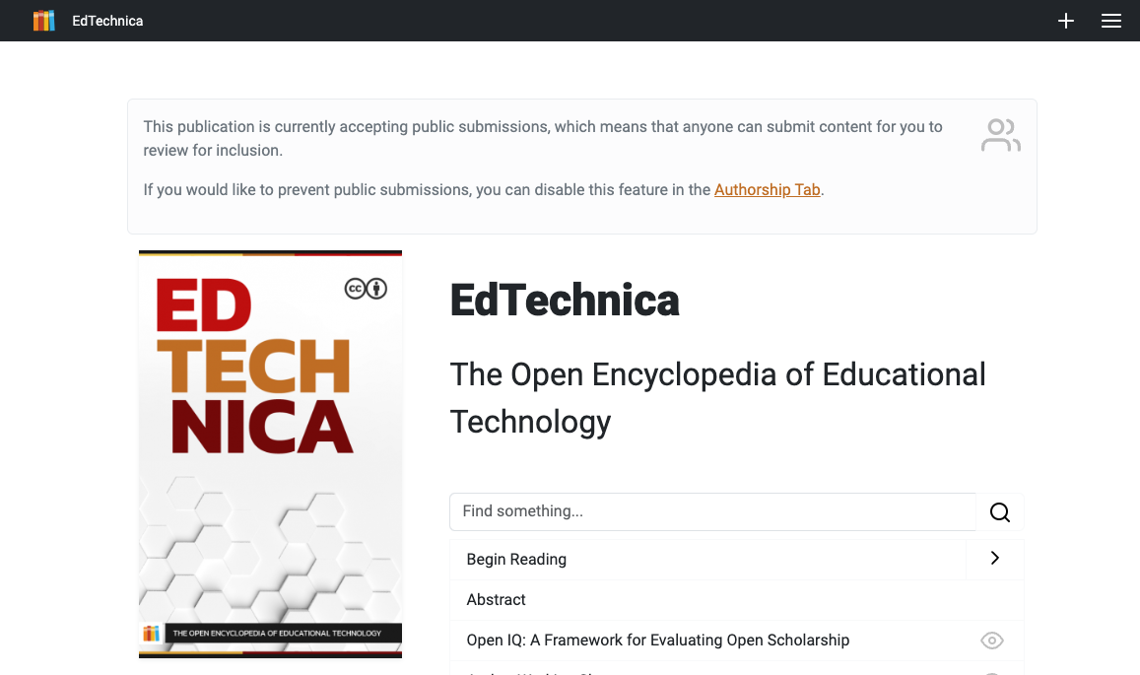

With this feature on, anyone can click the menu button and choose the Submit tab. You can also share this tab as a direct link in a call for proposals, email campaign, etc.

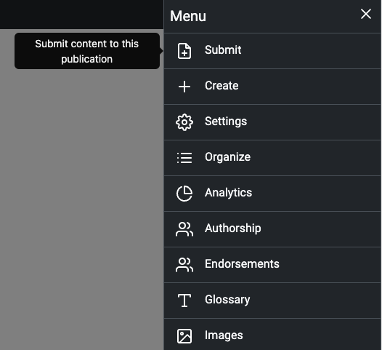

Once anyone clicks on the link, they will be prompted to login or to create an account and will then be able to fill out the submission form.

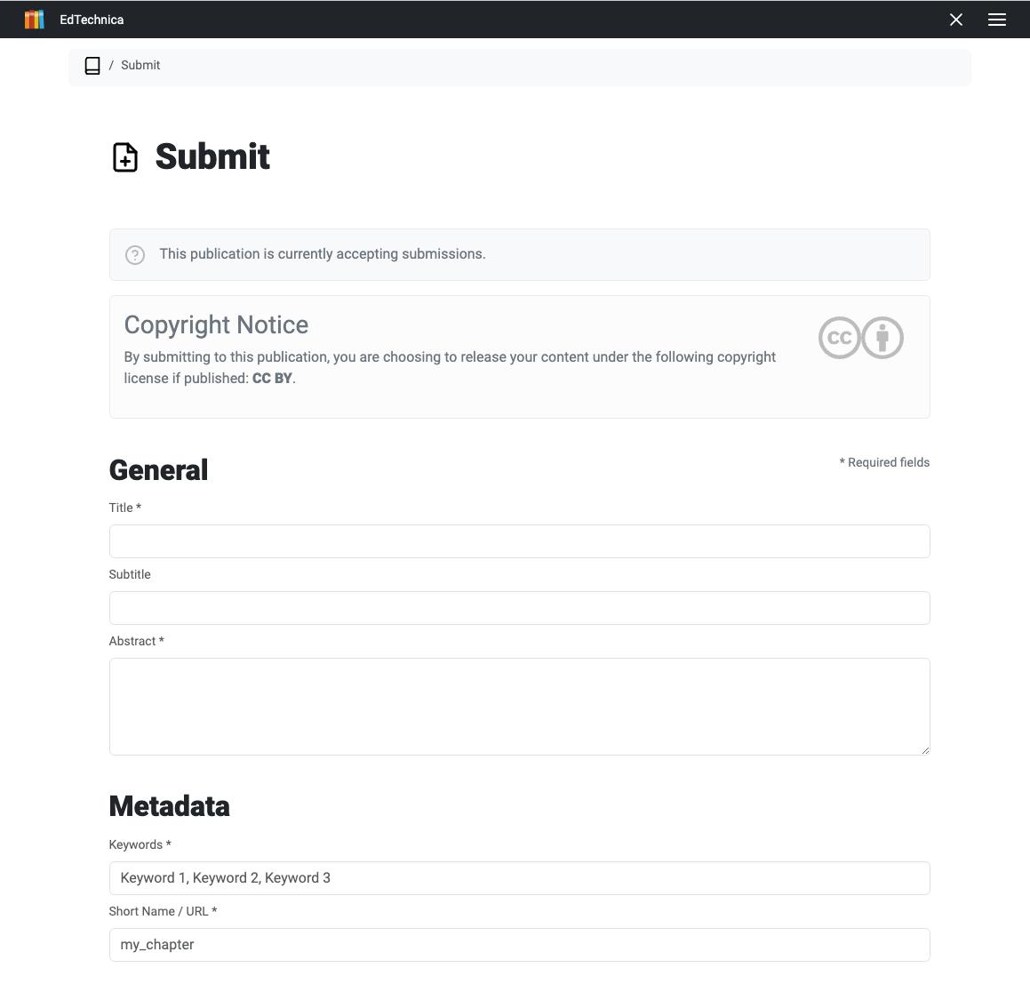

Once you are done collecting submissions, you should turn off public submissions on the Authorship page in order to prevent unwanted submissions. The reminder on your publication's cover page will remain visible to editors until this has been done.

Read this online at <https://ensign.edtechbooks.org/userguide/public_submissions>